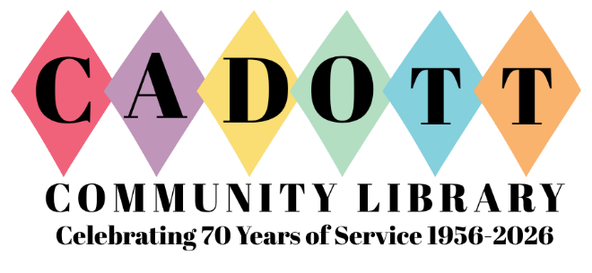
LIBRARY BOARD MEETING: Monday, July 13, 2026
TIME: 4:30 PM
PLACE: Cadott Community Library – 628 N State HWY 27
Virtual: bit.ly/caLibraryBoard
AGENDA:
- Call to order:
  - Roll call: Present:
  - Compliance with open meeting law
  - Action – Agenda
- Public Comment (Limit 3 Minutes)
- Discuss/Action: April Minutes
- Discuss/Action: Financials
  - Bills
  - Ledger(s)
- Discuss: Director’s Report
  - Summer and Fall Programs
- TABLED: Information: Collection Development Practices
  - Kotek: Draft Update
- Building Project Updates
  - Move/Reopening
    - Shelving & Furniture
    - Punch List items
    - Signage
- Discuss/Action: Purchasing
  - Opening Day Collection Carts
  - Equipment
    - Prime Day purchases made
      - Grant Reimbursable fitness/health items
    - Estimate on still-needed items
Adjourn

For additional accommodations, please contact the library director.
www.cadottlibrary.org ∙ 715-289-4950 ∙ cadottpl@cadottlibrary.org

