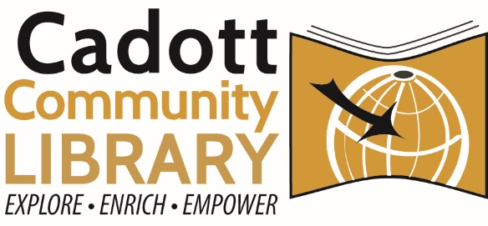
Capital Campaign Committee Meeting
Monday, June 12, 2025 – 4:30 PM
Cadott Community Library
Agenda:
- Full Committee Updates
  - Construction Bid Results
  - FFP Timelines/Updates
- Awareness Committee Updates
  - Groundbreaking
    - FOCCL Refreshments
    - “Open House”/Appreciation Week at the library
  - Donor Wall
  - Community Org. Visits
  - Yard Signs & Campaign Thermometer
  - Next Steps
- Capital Campaign Updates
  - Financial Report w/ Grant Updates
  - Business Donor Visits
  - Individual Donor Visits
  - Next Phase – EDDM Options (Every Door Direct Mail)
- Fundraising Event Brainstorming
- Other Recognition Considerations
- Upcoming Meetings

A quorum of Library Trustees may be present, but no library business will be discussed or acted on. If there are questions or a need for accommodation, please contact the library director at 715-289-4950 at least 24 hours before the meeting.

