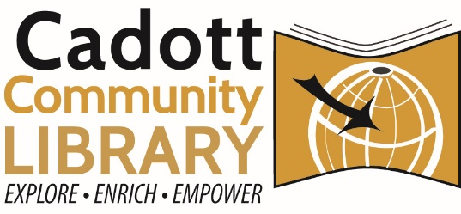
Social Media Policy and General Guidelines
Social media is defined as any form of electronic communication, such as websites for social networking. These sites are used to connect with community members, other libraries, and other interested parties to inform them of services, materials, events, and other literacy or community information.
- Scope
All social media accounts or profiles are to be created or approved by the Library Director. All library staff over the age of 18 may then use accounts on behalf of library marketing and engagement belong solely to the library.
Services of Social Media platforms are ever evolving. The Library Director will make informed decisions on the inclusion of the library’s presence on any social media platform. Library Staff are representations of the library while on social media under Library-Owned accounts.
- Audience
The library’s social media audience is primarily current or former residents of the Cadott Community and Chippewa County. A wider audience may include fellow MORE Consortium libraries, staff, and patrons, and IFLS Library System staff.
- Public Comment Guidelines
All commentary or messages to our social media accounts becomes part of the public record. By participating on the library’s social media pages, permission is given to reproduce, distribute, publish, display, edit, modify, delete, and otherwise use your submission for any library-related purpose, in any form, on any media.
The library services a population of nearly 3000 individuals. The library does not condone bias against any individuals based on race, gender, sexual orientation, economic status, etc. Everyone is welcome at the library and to communicate via the library’s online social media presence.
However, the library reserves the right to review, screen, edit, and delete comments, to ensure that comments are pertinent to the library’s purpose and mission, in accordance with the guidelines below.
- Post comments that are substantially off topic or unrelated to the original post.
- Use defaming, demeaning, vulgar, offensive, threatening, or harassing language or images.
- Advertise, promote, or solicit for any business, commercial transaction, or non-government service.
- Impersonate or misrepresent someone else.
- Post the same note more than once, or post obvious spam.
- Promote or oppose current ballot measures or persons seeking office unless directly related to a library program.
- Violate copyright of images, music, and video or published works without source credit or permission of the owner.
The library may occasionally refer to public comments made on social media. However, it will not collect, sell or knowingly transfer to any third party any personally identifiable information related to social media engagement with the library. Please be advised that every social media platform has its own privacy policies that should be carefully reviewed. All contents of the library’s information technology and communications systems are the property of the library.
- Staff Responsibilities
Staff administering social media accounts recognize that they are the digital face of the library. Posts on social media should be consistent with the library’s mission and values. Staff will interact with users on social media in a professional, diplomatic, and friendly manner, as they would in the physical library. Staff should refrain from expressing their personal views when posting on the library’s behalf.
Negative comments on library posts will not be deleted unless they violate public comment guidelines.
Social Media Best Practices Guidelines and Strategies
- Library staff will be responsible for understanding and abiding by the policies of each social media platform they engage with.
- If staff is unclear how to respond to a comment, they should refer the comment to the library director.
- Comments requiring response should be replied to in a timely manner. For social media, within hours if possible or at the latest by the end of the next workday.
- The library uses social media to promote its programs, services, and to engage with the community. Posts from library accounts relate back to its mission, programs, and services. Posts can recognize community partners, collaboration, or pertinent and timely information about matters in the community.

Adopted: 2024

