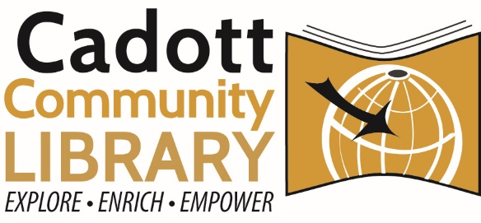
Capital Campaign Committee Meeting
Monday, April 14th, 2025 – 1 PM
Cadott Community Library
Agenda:
- Committee Updates (Cookie)
  - Board of Appeals Hearing, April 15
- Financial Report (Samma)
- Donor Updates (Samma, Patti)
  - Recognition/Thank Yous Sent
- 1st Donor Outreach Update
  - Letters Sent
  - CCC Contact Assignments
- Record Keeping
  - Updating Responsibilities & Reporter
- Assign Next Meeting Date

