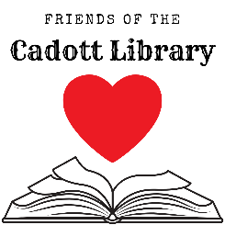
Friends of the Library Meeting
Tuesday, July 11, 2023
5 PM – Cadott Community Library

Agenda:
- Update on Accounts from Treasurer and Nonprofit Status
- Nabor Days Planning
  - Saturday at the Park
  - Sunday Parade
- Movie License renewal ($227)
- Member Comment/Other Business?
- Adjourn

