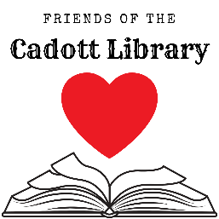
Friends of the Cadott Community Library
Quarterly Meeting: Saturday, October 12th, 2019
Cadott Family Restaurant, 11 AM

Agenda
- Call to Order
- Roll Call/Attendance
- Standing Business
  - Treasury Report
  - Current Fundraising
    - Results of Letter Writing campaign & Recent Book Sales
    - Coasters
- New Business
  - Director’s Report
    - Library news and updates
    - Wish list
      - Paying for Calendars & Bags
      - Snacks/Refreshments for programs
  - New Fundraising Ideas & Brainstorming
    - T-Shirts from CustomInk
    - Brainstorming List
  - Newspaper Ad to thank donors
- Additional Comments
- Adjournment

